Installation
- Uninstall the existing NAVFIT98A application, if applicable
- Download the NAVFIT98A to a temporary location on your workstation by click on link
http://www.public.navy.mil/BUPERS-NPC/CAREER/PERFORMANCEEVALUATION/Pages/SoftwareForms.aspx

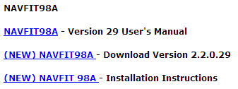
2.2.30
Version 30 User’s Manual

- Save the file to the temporary location
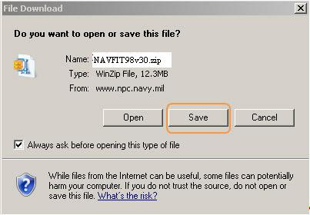

- Double click on the zip file and extract to a location of your choice.
The second way to unzip files in Windows 7 is to use the Unzip Wizard.
- Right-click the zipped file and select Extract All.
- Browse to the location where you want to save the unzipped files by clicking Browse if the default location is not good for you.
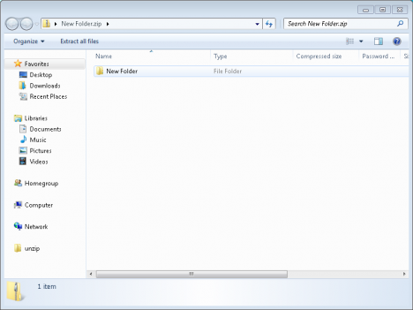
- Click Extract to unzip the files.

- Verify the NAVFIT98A application package contains the following files with the appropriate file extensions:
  - SETUP.EXE
  - NAVFIT98.msi
  - DotNetFX40Client Folder
  - WindowsInstaller3_1 Folder
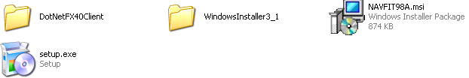

- Navigate to the temporary folder where the NAVFIT98A application package was copied
- Close all open programs in preparation of application installation
- Double-click Setup.exe to install the NafFit98A application
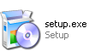

- Follow the on-screen instructions as prompted by the installation program. It is recommended that you accept the default location for the software installation. Depending on the workstation’s security configuration you may receive a warning message that says the following: “Do you want to allow the following program from an unknown publisher to make changes to this computer.” Select the Yes button to complete the installation process.
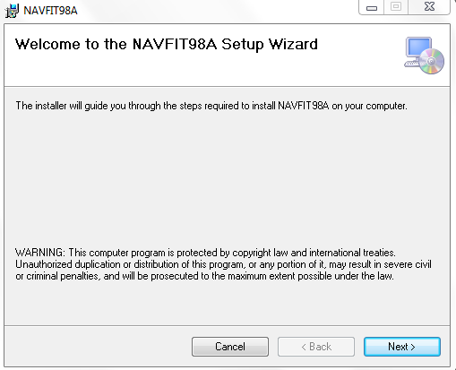
Select Next
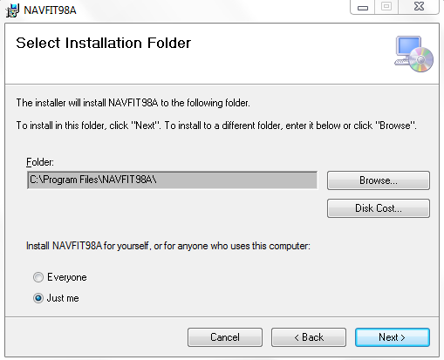
Select Next
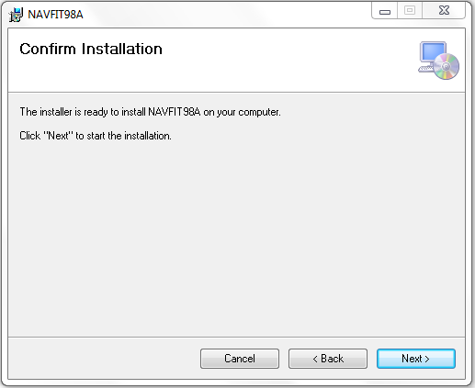
Select Next
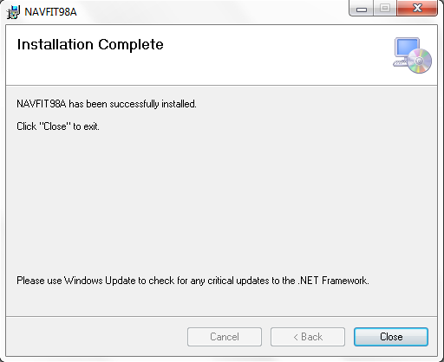
Select Close
Note: NAVFIT98A Version 30 requires Microsoft .NET Framework 4 Client to operate properly. If your workstation does not have the .NET framework the installation package will install the required software to your workstation.

- Once you receive the successful installation message, you should find a NAVFIT98A entry in your ‘All Programs’ menu. Select the NAVFIT98A entry internal to the NAVFIT98A menu item to launch the application.

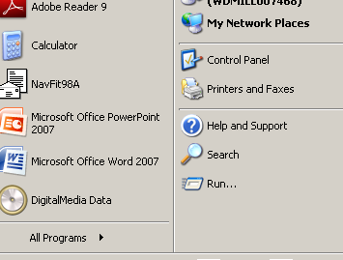

Note; Depending on your system settings (especially with the Vista operating system) you may need to have FULL administrator rights including domain administrator to install and operate the application.
How to run a program in Vista with Administrator Rights:
- Browse to the program you would like to launch as an administrator
- Right click the program icon and select the option to "Run as administrator"
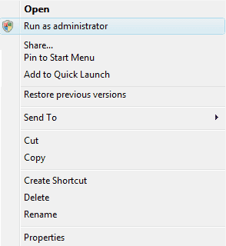
If all works well when the program is run as administrator, you can opt to always run the program as administrator. In addition, you might want to run the program in compatibility mode for an older version of Windows.
How to set a program to always run as administrator:
- Locate the program you want to launch with admin rights
- Right click the program icon and choose the properties option
- Select the compatibility tab from the window that appears
- At the bottom of the window, under privilege level, check the box to run this program as administrator
Note: you may also want to run this run this program in compatibility mode if it was originally created for another version of Windows such as Windows XP. To do this action, check the box to run this program in compatibility mode for: and then select the compatible Windows environment from the drop down menu.
- Once finished setting your options, click Apply to accept the changes
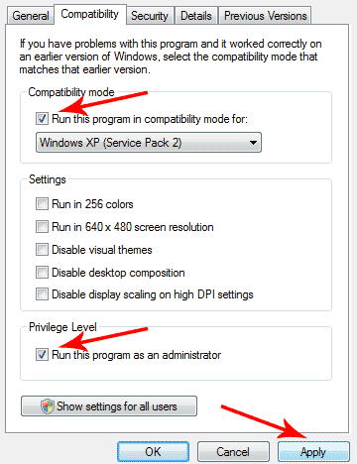

This step-by-step article describes how to enable the build-in administrator account by command-line in Windows Vista.
To enable the build-in Administrator account, follow these steps:
1. Click Start, and then type cmd in the Start Search box.
2. In the search results list, right-click Command Prompt, and then click Run as Administrator.
3. When you are prompted by User Account Control, click Continue.
4. At the command prompt, type net user administrator /active:yes, and then press ENTER.
5. Type net user administrator <Password>, and then press ENTER.
Note: Please replace the <Password> tag with your passwords which you want to set to administrator account.
6. Type exit, and then press ENTER.
7. Log off the current user account
NOTE: When creating a database the following error message is received: System.Runtime.InteropServices.COMException (0x80040154): Class not registered means your workstation needs an updated driver:
To download the correct driver, take the following steps:
1) navigate to the Microsoft site - http://www.microsoft.com/download/en/confirmation.aspx?id=23734
2) download the 2007 Office System Driver: Data Connectivity Component and save the file to your computer
3) double-click the "AccessDatabaseEngine.exe" program file from your chosen storage location on your computer
4) follow the on-screen Microsoft installation instructions
5) upon successful installation, you will need to reboot the computer before attempting to launch NAVFIT98A

Hardware Requirements:
Processor: minimum 1GHz
RAM: minimum 512 MB
Disk space: 32 bit-850 GB
64 bit-2 GB
Operating Systems:
All Windows 7 Editions
All Windows Vista Editions
Windows XP Professional
Windows XP Professional x64 Edition
Windows XP Home Edition

